HACK FOR SOCIAL CAUSE | HSC-27 HACKATHON SUBMISSION
BlueHawk Civic Nexus: Autonomous Edge-AI Street Rover & GIS Urban Governance Grid for Proactive Emergency Threat Alerting and Sustainable Municipal Action

Problem Statement / Concept Title | BlueHawk Civic Nexus - H.A.W.K. Edge-AI Street Rover + BlueBridge GIS Urban Governance Grid
Theme | Theme 4: Governance & Civic Technology | Theme 7: AI, GIS & Emerging Technologies
Team Name (Registered on portal) | BlueHawk Civic Nexus
Team ID (Registered on portal) | [ENTER TEAM ID EXACTLY AS SHOWN ON PORTAL]
State / UT | Uttar Pradesh

ALIGNED WITH UN SUSTAINABLE DEVELOPMENT GOALS
SDG 3  Good Health & Well-being |  | SDG 9  Industry, Innovation & Infrastructure |  | SDG 11  Sustainable Cities & Communities |  | SDG 16  Peace, Justice & Strong Institutions

Lead Innovator: Aravind K. T., B.Tech Electrical Engineering (Class of 2028), IIT Kanpur | Live App: https://bluehawk-civic-nexus.streamlit.app

THE DWIVIDHTA (DUALITY) FRAMEWORK: closing the gap between what the city shows and what the system misses
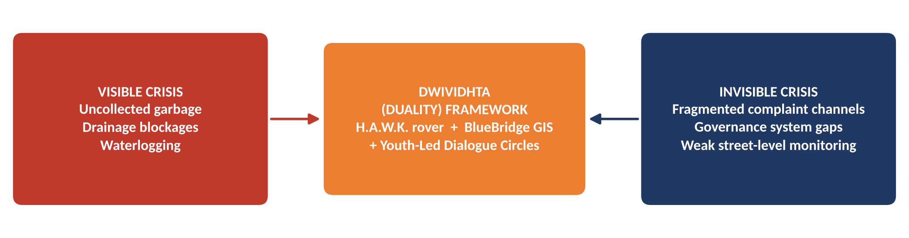
CORE PROBLEM |  | PROPOSED SOLUTION |  | INNOVATION & UNIQUENESS
- Dual visibility crisis in urban and semi-urban wards  - Visible: uncollected garbage, drainage blockages, waterlogging  - Invisible: governance gaps and weak street-level security monitoring in vulnerable corridors  - Complaints scattered across unlinked channels |  | - Closed-loop hybrid ecosystem with two linked halves  - H.A.W.K.: low-cost autonomous street patrol rover  - BlueBridge: AI/NLP classification + PostgreSQL/PostGIS spatial GIS grid  - One pipeline: detect, classify, locate, route, act, learn |  | - Bridges embedded robotics with cloud GIS analytics  - Splits every alert into Path A (emergency) or Path B (municipal)  - Pairs technical precision with community empathy via Youth-Led Peace & Dialogue Circles  - Low-cost, modular, open-source

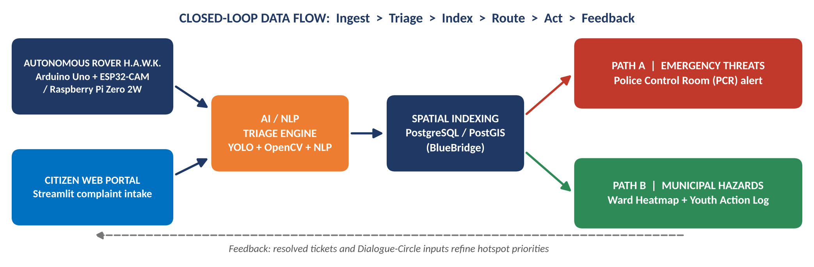
HARDWARE STACK |  | SOFTWARE & AI STACK |  | LIVE LINKS & AI DISCLOSURE
- Arduino Uno R3 + Adafruit Motor Shield  - HC-SR04 ultrasonic, IR line/proximity, UV sensors  - Metal-gear servos  - Edge vision nodes: ESP32-CAM / Raspberry Pi Zero 2W |  | - Python: Streamlit, Pandas, NumPy  - OpenCV + YOLO (vision); NLP models (text triage)  - PostgreSQL / PostGIS spatial database  - Open-source throughout |  | GitHub: https://github.com/kt2141/BlueHawk-Civic-Nexus  Live App: https://bluehawk-civic-nexus.streamlit.app  Demo Video: [PASTE DEMO VIDEO LINK]  AI usage: YOLO/OpenCV + NLP power the core classifier. Generative AI assisted ~15-20% (formatting only). Hardware design, Arduino firmware and governance frameworks are 100% original.

25-40%  Projected faster cleanup & emergency response |  | 2 PATHS  Emergency vs municipal routing, automatic |  | 1 GRID  All complaints unified on one PostGIS map |  | 5  Stakeholder groups connected

IMPACT ON TARGET AUDIENCE |  | BENEFITS |  | STAKEHOLDERS
- Residents: faster fixes, one place to report, visible follow-through  - Vulnerable corridors: proactive patrol coverage and earlier threat alerts  - Quantitative: 25-40% faster cleanup and emergency response via spatial routing and automated hotspot prioritization (projected target, to be validated in pilot) |  | - Social: enhanced public safety; structured youth empowerment  - Health: fewer garbage, drainage and waterlogging hazards  - Governance: higher administrative transparency and accountability  - Economic: low-cost hardware; crews dispatched where need is highest |  | - Citizens: report and track  - Municipal Workers: prioritized, mapped tasks  - Police Control Rooms: verified emergency alerts  - Youth Volunteers: Action Log and Dialogue Circles  - Urban Policymakers: ward-level heatmap evidence

Dimension | Today (fragmented) | With BlueHawk Civic Nexus
Complaint handling | Unlinked channels, no common map | One geotagged queue on the PostGIS grid
Emergency alerts | Manual, delayed street-level monitoring | AI-triaged Path A alert straight to the PCR
Cleanup planning | Reactive, complaint by complaint | Hotspot-prioritized routing from the ward heatmap
Youth role | Ad hoc volunteering | Structured Youth Action Log + Dialogue Circles

LOW COST  Arduino / ESP32 modular parts |  | OPEN SOURCE  PostGIS + Python stack |  | WORKING  Live app + public GitHub repo |  | PHASED  Managed corridors first

FEASIBILITY ANALYSIS: HIGH VIABILITY
- Technical: modular, low-cost parts (Arduino / ESP32) - each module can be built, tested and replaced independently
- Software: open-source PostGIS architecture, no licence cost; live Streamlit app and public GitHub repository already available
- Deployment: phased - managed campus / ward corridors first, then wider wards

POTENTIAL CHALLENGES, RISKS & STRATEGIES
Risk / Challenge | Level | Mitigation Strategy
Terrain obstacles and hardware wear | Medium | Restrict initial deployments to managed campus / ward corridors; lightweight plastic/rubber wheel configuration; scheduled maintenance
Public adoption friction | Medium | Pair rover patrols with Youth-Led Peace & Dialogue Circles to build community trust and transparency
False alarms on emergency path | Medium | Confidence thresholds in the AI triage engine; human verification at the Police Control Room before dispatch
Privacy and data protection | Medium | Process on the edge node, store only geotagged event records, role-based access to the GIS grid

PHASED ROLLOUT
PHASE 1: PILOT |  | PHASE 2: WARD EXPANSION |  | PHASE 3: CITY INTEGRATION
Managed campus / ward corridors; validate detection accuracy and response-time gains |  | More rovers and corridors; Youth Action Log and Dialogue Circles scaled up |  | Link with municipal systems and Police Control Room workflows

NATIONAL AWARD  Devbhoomi Rashtriya Ratna Puraskar 2025 |  | UN GENEVA  UN Social Forum 2025 delegate |  | NTU SINGAPORE  i-SEA Fellow 2026 |  | PARIS 2026  Global Youth Festival delegate

TEAM COMPOSITION & ROLES |  | CHALLENGES OVERCOME |  | JOURNEY & MILESTONES
Aravind K. T. - Lead Innovator  B.Tech Electrical Engineering (Class of 2028), IIT Kanpur, Hall of Residence 5; AISHE Code U-0517  - Robotics hardware & Arduino firmware  - AI/NLP triage and PostGIS / Streamlit platform  - Governance framework and youth-engagement model  Leadership: Former Secretary, Public Policy & Opinion Cell (IIT Kanpur); Founder, Youth-Led Peace & Dialogue Circles (Karnataka); UPG Sustainability Champion; UNESCO APCEIU GCED Certified; Official ICSC Ambassador |  | - Weight and traction: moved from heavy mild-steel wheels to optimized plastic/rubber configurations  - Thermal servo loads: diagnosed and resolved overheating under load  - Integration: united embedded hardware, cloud GIS and AI into one closed-loop pipeline  - Trust: linked technology to grassroots dialogue, not just dashboards |  | - Devbhoomi Rashtriya Ratna Puraskar 2025: National Award for Outstanding Contribution to Youth Welfare  - Youth Leadership Outstanding Awardee: Top 50 Youth Leaders in Asia-Pacific, Seoul  - UN Social Forum 2025: Officially accredited delegate, Palais des Nations, Geneva  - i-SEA Fellow 2026: Nanyang Technological University (NTU), Singapore  - My Bharat Budget Quest 2026: National Finalist, top among 13 lakh+ participants  - Global Youth Festival 2026, Paris: Fully funded delegate selection

Reference | Details / Link
Digital Portfolio (Aravind K. T.) | https://sites.google.com/view/aravind-k-t-iitk/
Open-Source Code (GitHub) | https://github.com/kt2141/BlueHawk-Civic-Nexus
Live Deployment (Streamlit) | https://bluehawk-civic-nexus.streamlit.app
Institutional Guidelines | Ministry of Youth Affairs & Sports (MoYAS) and IIT Bombay VBYLD 2027 Framework
UN Sustainable Development Goals 3, 9, 11, 16 | https://sdgs.un.org/goals
Technology documentation | PostGIS (postgis.net) | OpenCV (opencv.org) | Streamlit (streamlit.io) | Ultralytics YOLO (docs.ultralytics.com) | Arduino (arduino.cc)

VERIFICATION SUMMARY
Innovator: Aravind K. T., IIT Kanpur (AISHE Code U-0517) | Team: BlueHawk Civic Nexus | State: Uttar Pradesh | Themes: 4 and 7 | SDGs: 3, 9, 11, 16
Originality: hardware design, Arduino firmware and governance frameworks are 100% original; generative AI assisted ~15-20% of formatting only.

